ASSIGMENT 7.3
NAME:JAHNAVI REDDY
BATCH:27
HALL TIC: 2303A51839
Lab 7: Error Debugging with AI
Systematic approaches to finding and fixing bugs
Task 1: Fixing Syntax Errors
Buggy Code (missing colon):
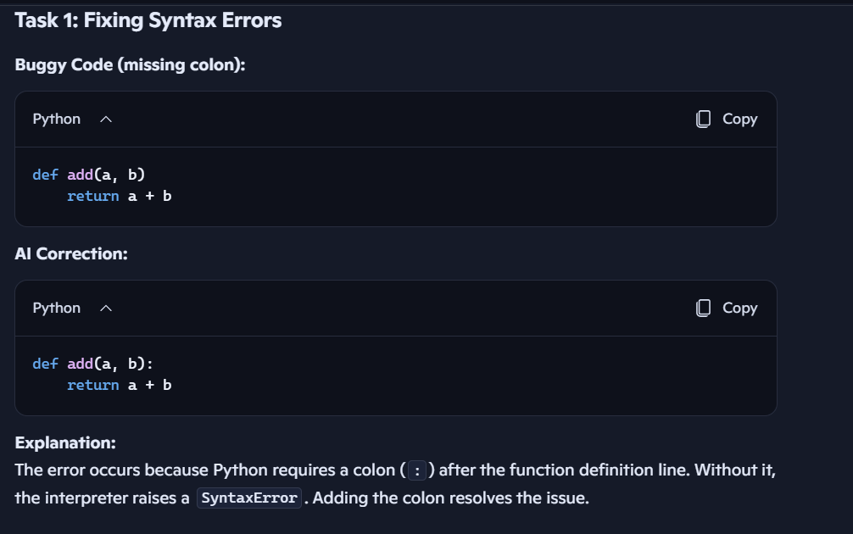
Task 2: Debugging Logic Errors in Loops
Task 3: Handling Runtime Errors (Division by Zero)
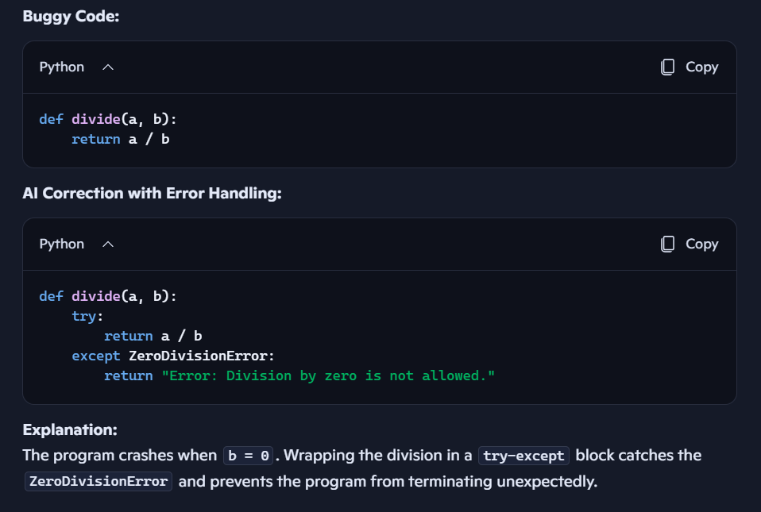
Task 4: Debugging Class Definition Errors
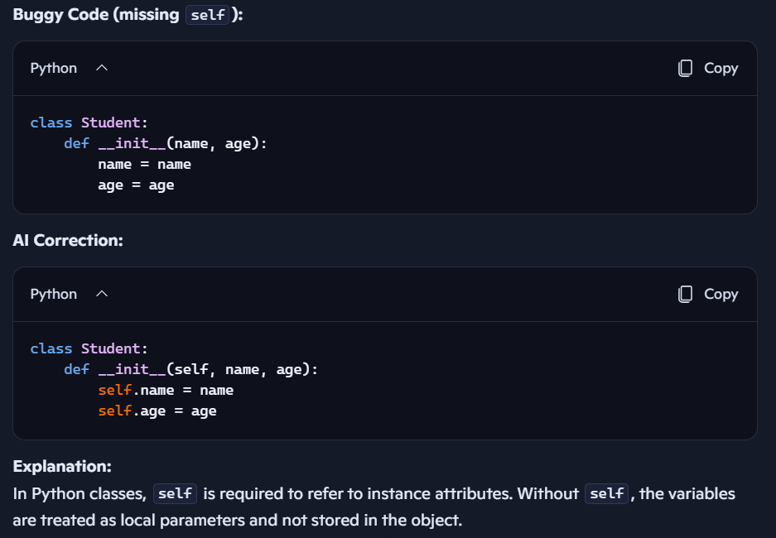
Task 5: Resolving Index Errors in Lists
